**Deep Learning Assignment-01**

*Submitted by*

***Samahit Mahapatra***

**A124009**

**Master of Technology**

**In**

**Computer Science and Engineering**



**INTERNATIONAL INSTITUTE OF INFORMATION**

**TECHNOLOGY, BHUBANESWAR**

**ODISHA, 751003 INDIA**

**Solutions of Deep Learning Assignment 01**

**Q1. For a D -dimensional input vector, show that the optimal weights can be represented by the expression: l**

**w = (XTX)−1XTt**

**What is the possible estimation of w?**

**Solution:**

This expression represents the optimal weights (or coefficients) in a linear regression model when using the ordinary least squares (OLS) method.

Given:

Input matrix X of size N×D, where:

N = number of samples

D = number of features

Target vector t of size N×1, containing the true output values

Weight vector w of size D×1, which we want to estimate

Optimal Weight Solution:

The optimal weights w that minimizes the sum of squared errors (SSE) between the predicted outputs Xw and the true outputs t are given by the normal equation:

w = (XTX)−1XTt

Derivation:

1. The linear regression model predicts:

$\hat{t}$ = Xw

1. The error (residual) is:

Error = t−Xw

1. The sum of squared errors (SSE) is:

SSE = (t−Xw)T (t−Xw)

1. To minimize SSE, taking the gradient w.r.t. w and set it to zero:

∇w SSE = −2XT(t−Xw) = 0

1. Solving for w, we get:

XTXw = XTt

1. If XTX is invertible, the solution is:

w=(XTX)−1XTt

Possible Estimation of w:

* If N≥D and X has full rank, then w is uniquely determined.
* If N<D (fewer samples than features), XTX is singular (non-invertible), and infinitely many solutions exist.

If XTX is nearly singular, small perturbations in X can lead to large changes in w. Regularization helps stabilize the solution.

Hence, the optimal weight vector w is estimated as:

w=(XTX)−1XTt

This is the best linear unbiased estimator (BLUE) under the Gauss-Markov assumptions. If the assumptions are violated, alternative methods (e.g., weighted least squares, robust regression) may be needed.

**Q2. OR Gate in single neural network**

**Solution:**

The OR gate is a fundamental logic gate that outputs 1 if at least one of its inputs is 1. We can model this using a single-layer perceptron (SLP), which is the simplest form of a neural network.

Truth Table for OR Gate:

|  |  |  |
| --- | --- | --- |
| X1 | X2 | Output(t) |
| 0 | 0 | 0 |
| 0 | 1 | 1 |
| 1 | 0 | 1 |
| 1 | 1 | 1 |

Perceptron Model for OR Gate:

A single-layer perceptron consists of:

* Inputs: x1, x2 (binary values: 0 or 1)
* Weights: w1,w2
* Bias: b
* Activation Function:

Step function (Heaviside function):

Output = $\left\{\begin{aligned}1 if z≥0, \\ 0 if z<0,\end{aligned}\right.$

where z =w1x1 + w2x2 + b

Finding Weights and Bias:

We need to find w1, w2, b such that the perceptron correctly classifies all OR gate inputs.

Possible Solution:

One valid set of weights and bias is:

w1 = 1

w2 = 1

b = −0.5

Verification:

* Input (0, 0): z = (1)(0)+(1)(0)−0.5= −0.5 $⟹$ Output = 0 (Correct)
* Input (0, 1):

z = (1)(0)+(1)(1)−0.5 = 0.5 $⟹$ Output = 1 (Correct)

* Input (1, 0):

z = (1)(1)+(1)(0)−0.5 = 0.5 $⟹$ Output = 1 (Correct)

* Input (1, 1):

z = (1)(1)+(1)(1)−0.5 = 1.5 $⟹$ Output = 1 (Correct)

Therefore, this perceptron correctly implements the OR gate

**Q3**. :**for given graph give the following solutions,**

1. **Generalized Point of Intersection for Shallow Neural Networks for input space parameterized by spherical coordinates θ and ϕ**

Solution:

Generalizing the Point of Intersection in Terms of θ and ϕ for Shallow Neural Networks

Step 1: Structure of a Shallow Neural Network

Let us consider a shallow neural network with:

* Input dimension: d
* Number of hidden neurons: m
* Activation function: σ
* Weight vectors: wi ∈ $w_{i}∈ R^{d}$
* Bias terms: bi ∈
* Output weights: ai ∈

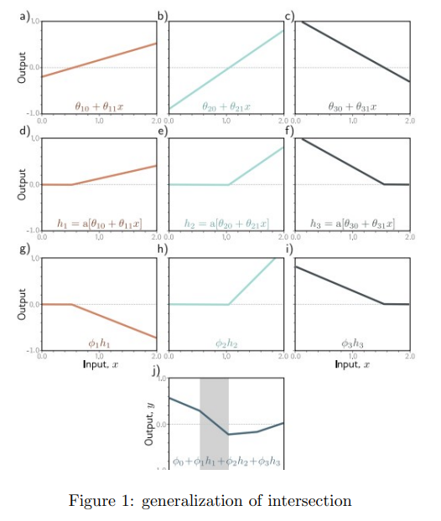

The output of the network is given by:

$$f\left(x\right)=\sum_{i=1}^{m}{a_{i}σ\left(w_{i}^{T}x+ b_{i}\right)}$$

Step 2: Weight Vectors in Angular Coordinates

In spherical coordinates:

$$w= \left\|w\right\| = \left[\begin{matrix}\sin\left(θ\right)\cos\left(∅\right) \\ \sin\left(θ\right)\sin\left(∅\right) \\ \cos{θ}\end{matrix}\right]$$

Step 3: Decision Boundary Condition

For each neuron, the decision boundary satisfies:

$$w_{i}^{T}x+b_{i}=0$$

which in spherical coordinates becomes:

$$\left\|w\right\|\left[x_{i}\sin\left(θ_{i}\right)\cos\left(∅_{i}\right)+ x_{2}\sin\left(θ_{i}\right)\sin\left(∅_{i}\right)+x_{3}\cos\left(θ\right)\right]+b_{i}=0$$

Step 4: Intersection of Decision Boundaries

If two neurons intersect, we solve the system:

$$w_{i}^{T}x+ b_{i}=0, w_{j}^{T}x+ b_{j}=0$$

which translates to:

$$\left\|w_{i}\right\|x.v\left(θ_{i},∅_{i}\right)+ b_{i}=0, \left\|w_{j}\right\|x.v\left(θ_{j},∅_{j}\right)+ b_{j}=0$$

Step 5: General Solution

The point of intersection x can be computed by solving the linear system:

$$x=A^{-1}b$$

where A is the matrix formed by the weight directions in spherical coordinates and b is the bias vector.

1. Give the equation of 4-line segment in graph in, $θ_{1},θ_{2},θ_{3}$ etc. for figure

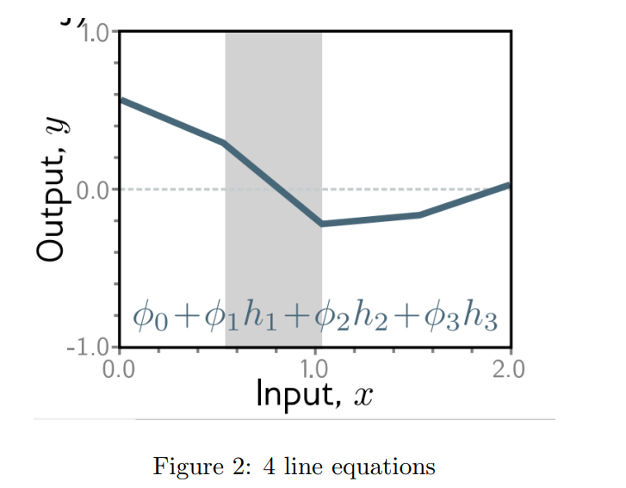

Solution:

Let us consider a shallow neural network with three hidden units and ReLU activations. Let the output y of the network be defined by the following equation:

$$y= ∅_{0}+ ∅_{1}h_{1}+ ∅_{2}h_{2}+ ∅_{3}h_{3}$$

where each hidden unit $h_{i}$ is given by the ReLU activation function:

$$h_{i}=a\left(θ_{i0}{ + θ}_{i1}x\right)=max\left(0,θ_{i0}{ + θ}_{i1}x \right)$$

The output y(x) is composed of four linear segments, which can be written as: $y\left(x\right)=\left\{\begin{aligned}\begin{aligned}∅_{0}, x< x_{1} \\ ∅_{0}+∅_{1}\left(θ_{10}θ_{11}x\right), x_{1}≤x< x_{2}\end{aligned} \\ ∅_{0}+∅_{1}\left(θ_{10}θ_{11}x\right)+ ∅_{2}\left(θ_{20}θ_{21}x\right), x_{2}≤x< x_{3} \\ ∅_{0}+∅_{1}\left(θ_{10}θ_{11}x\right)+ ∅_{2}\left(θ_{20}θ_{21}x\right)+∅_{3}\left(θ_{30}θ_{31}x\right) x_{1}≤x< x_{2}\end{aligned}\right.$

Explicitly, the four-line segments are:

* First segment: y = ϕ0
* Second segment: y = ϕ0 + ϕ1(θ10 + θ11x)
* Third segment: y = ϕ0 + ϕ1(θ10 + θ11x) + ϕ2(θ20 + θ21x)
* Fourth segment: y = ϕ0 + ϕ1(θ10 + θ11x) + ϕ2(θ20 + θ21x) + ϕ3(θ30 + θ31x)

The activation thresholds x1, x2, and x3 where each hidden unit is activated are given by:

$x_{i}= -\frac{θ_{i0}}{θ_{i1}}$, for each neuron.

The output function combines all the active hidden units according to their weights and it is expressed in the above form.

**Q4. :Let x1, x2, . . . , xn be independent and identically distributed (i.i.d.) vectors from a multivariate normal distribution:**

$$x_{i}∼N\left(μ,Σ\right)$$

**where µ is the unknown mean vector and Σ is the known covariance matrix.**

Solution:

Maximum Likelihood Estimate of Unknown Mean Vector

Let x1, x2, . . . , xn be independent and identically distributed (i.i.d.) vectors from a multivariate normal distribution:

$$x_{i}∼N\left(μ,Σ\right)$$

where µ is the unknown mean vector and Σ is the known covariance matrix.

The probability density function (PDF) of xi is given by:

$$f\left(x_{i}\left|μ\right.\right)= \frac{1}{{(2π)}^{p/2}{\left|Σ\right|}^{1/2}}exp\left({-\frac{1}{2}\left(x_{i}-μ\right)}^{T}Σ^{-1}\left(x_{i}- μ\right)\right)$$

Likelihood Function:

Given the independence of the samples, the likelihood function is the product of the individual densities:

$$L\left(μ\right)= \prod_{i=1}^{n}{f\left(x_{i}\left|μ\right.\right)}$$

Taking the natural logarithm of the likelihood function (log-likelihood):

$$\log{L\left(μ\right)= -\frac{np}{2}\log\left(2π\right)- \frac{n}{2}\log\left|Σ\right|- \frac{1}{2}\sum_{i=1}^{n}{{\left(x_{i}-μ\right)}^{T}Σ^{-1}\left(x_{i}- μ\right)}}$$

Maximizing the Log-Likelihood:

To find the MLE of µ, we differentiate log L(µ) with respect to µ and set the result to zero:

$$\frac{∂\log{L}}{∂μ}= \sum_{i=1}^{n}{Σ^{-1}\left(x_{i}-μ\right)}=0$$

Simplifying:

$$\sum_{i=1}^{n}{\left(x_{i}-μ\right)}=0 ⟹n\hat{μ}= \sum_{i=1}^{n}{x_{i}}$$

Result: MLE of Mean Vector

$$\hat{μ}=\frac{1}{n}\sum_{i=1}^{n}{x_{i}}$$

Hence, the maximum likelihood estimate of the unknown mean vector is the sample mean.